Student Name
Teacher


Assessment task

Psychology –

GENERAL Year 11

Task 1 – Unit 1
Assessment type: Investigation- Data Interpretation

Conditions

Time allowed for completion of the task: 55 minutes

Task weighting

10% of Unit 1

To be provided by the supervisor:
This Question/answer booklet

To be provided by the candidate

Standard items: Pens, pencils, eraser or correction fluid, ruler, highlighter

Special items: Non-programmable scientific calculator

Structure of this paper

Section | Number of questions available | Suggested working time  (minutes) | Your Mark | Marks available | Percentage
Section One:  Short Answer | 6 | 55 |  | 42
 |  | Total |  | 42 | /100

Important note to candidates

No other items may be used in this test. It is your responsibility to ensure that you do not have any unauthorised notes or other items of a non-personal nature in the test room. If you have any unauthorised material with you, hand it to the supervisor before reading any further.

Data Interpretation

- Dr Stevens conducted a study with a group of Psychology students to determine the relationship between the numbers of hours spent studying Psychology per week and the final examination score. The results of this study are shown in the table below.
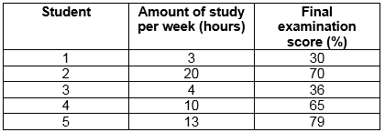

  - State the median examination score from this group. ____________________________
(1 mark)
  - Calculate the mean number of hours studied by this group. ____________________________
(1 mark)
  - Calculate the range of examination scores from this group. ____________________________
(1 mark)

  - Plot a scattergram of these scores on the axes provided. Label the scattergram appropriately.
(5 marks)

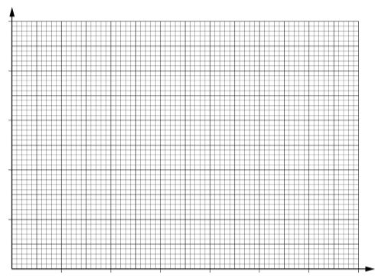

- Researchers are designing an experiment to determine whether listening to music while exercising causes people to exercise harder. There will be 100 participants in the experiment, 50 in the experimental group, and 50 in the control group.

  - List two variables that should be controlled in this experiment.
One: _______________________________________________________________________
Two: ________________________________________________________________________
(2 marks)
  - Identify one ethical consideration relevant to this study. Explain how the researchers would deal with this consideration in their research.
________________________________________________________________________________________________________________________________________________________________________________________________________________________________________________________________________________________________________________________________________________________________________________________________________________
(2 marks)

- The coach at a local under 18’s soccer team is concerned over the number of players that are missing games due to illness. He decides to investigate whether vitamins would decrease the amount of colds his team is experiencing.

  - Identify the independent variable and the dependent variable.
Independent: _____________________________________________________________________________
Dependent: _____________________________________________________________________________
(2 marks)
  - Identify two variables he can control.
- _____________________________________________________________________________
- _____________________________________________________________________________
(2 marks)
  - Identify two variables he cannot control.
- _____________________________________________________________________________
- _____________________________________________________________________________
(2 marks)
  - Name and explain one ethical consideration the coach needs to follow and include how he can achieve this.
________________________________________________________________________________________________________________________________________________________________________________________________________________________________________________________________________________________________________________________________________________________________________________________________________________
________________________________________________________________________________
________________________________________________________________________________
(3 marks)
- A psychologist collected data on the self-esteem of ten young people who were currently involved in volunteer work in their community, using a Likert scale.
The Likert scale produced scores for each person ranging from 10 to 50. Higher scores indicated higher levels of self-esteem.

The self-esteem scores for the 10 young people were:
30, 32, 38, 40, 45, 43, 46, 38, 45, 46

  - Complete the frequency table below.
(1 mark)
Self-esteem score | Number of people
11–15
16–20
21–25
26–30
31–35
36–40
41–45
46–50
Total

  - The psychologist is writing a report on the results of the research and needs to include a graph of the frequency of self-esteem scores. Graph the results from the frequency table in question 4 a) on the axes below.
(4 marks)
Frequency of self-esteem scores in volunteers

- Dr Warr was interested in the effects of social media on teens. He asked his friend Ayla if he could use her four adolescent children in his study and follow their use of social media. Ayla agreed that her 13-year-old twins Shae and Nyah, her 15-year-old son Zion, and her 18-year-old son Zhaun could be a part of Dr Warr’s study.

  - Ayla was not the only one who needed to give permission for her children to be a part of Dr Warr’s study. Identify another individual who needed to give consent and explain why they also needed to give consent.
________________________________________________________________________________
________________________________________________________________________________
(2 marks)
  - Dr Warr continued to follow the social media use of Ayla’s children for the next five years. At which time Zion finished school and decided to move overseas to go to university. He told Dr Warr that he would no longer be participating in his study. Name the ethical right he followed.
________________________________________________________________________________
(1 mark)
The table below represents some of the data Dr Warr collected on Ayla’s children in 2011.
 | Facebook | Instagram | Snapchat | Twitter
Nyah | 1555 | 460 | 856 | 29
Shae | 1200 | 980 | 320 | 26
Zion | 765 | 460 | 10 | 49
Zhaun | 205 | 6 | 2 | 31
Table 1: Number of hours spent in 2011 on various forms of social media

  - Calculate the mean amount of time Ayla’s children spent on Facebook in 2011.
________________________________________________________________________________
(1 mark)
  - Identify the range for the amount of time the siblings spent on Snapchat.
________________________________________________________________________________
(1 mark)
  - Identify which sibling, on average across the various forms of social media spent the most time on social media in 2011. Record the amount of time they spent.
________________________________________________________________________________
(2 marks)
- Macy was interested in studying the relationship between age and weight. She collected data from a range of people and created the following graph. However, she forgot to label the axis and give the graph a title.

  - Complete Macy’s graph by giving it and appropriate title in the correct place and labelling the X and Y axis.
(4 mark)
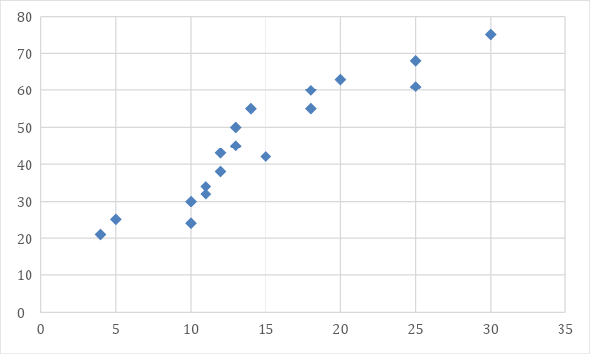

  - What type of graph did Macy create?
________________________________________________________________________________
(1 mark)
  - Provide a possible hypothesis for Macy’s research.
________________________________________________________________________________
________________________________________________________________________________
(2 marks)

  - Explain how Macy will ensure the ethical consideration of informed consent will be met in this investigation.
________________________________________________________________________________
________________________________________________________________________________
________________________________________________________________________________
(2 marks)
END OF TEST

